# 1. Introduction

Church donations are a very significant part of a Church Financial Department. A Church requires a secretary to keep track of all the donations. An existing system is used by the secretary to keep records of all accounts and donations. The secretary needs a new system to keep up with new updates and work. The new application is needed to be similar to the existing, but with robust features to support the needs of the secretary. The secretary will use the application to enter donations, member’s records, and print reports.

## Purpose of Plan Document

The purpose of the Project Plan Document is to define the key roles identified during the development of the application. It would indicate the team structure and the roles played by the team members. This plan outlines the different areas of the project that must be addressed for successful development of the software. Control and tracking mechanisms of the application are mentioned in this document. It specifies potential risks, its impact, and strategies to be followed to achieve the risk free environment. Also, quality assurance will be mentioned, and a glossary of terms used in this document is included. It establishes guidelines for resources that will be used in the project, and also points out additional resources that are needed.

## Project Scope and Objectives.

### 1.2.1 Statement of Scope

### The scope of this document is the development team should provide a software application to the Church Financial Department. This application would keep track of donations made to the Church. The secretary plays a key role which is identified in this scenario. A graphical user interface (GUI) will be designed keeping in mind that application should be user friendly. The development team will incorporate visual representation of data to make the GUI comprehensible. This project is estimated to be completed in one semester and all the required documents, including the user manual, will be released within the stipulated time.

### 1.2.2 Major Functions

The main function of the new system is to replace the existing system procedures in such a way that, the secretary can keep donation records and generate reports. Basic functionality of software is to create new funds and edit existing funds (Change name of funds).

The software should provide a Graphical User Interface (GUI) to create a record of information for each new donor. The application should allow the user to search members based on envelope numbers. Also, software should automatically retrieve details of the members from the database. The software allows the user to edit and update information of an existing donor into the database. The user can create a new record for each specific donation made to the Church. Also, the user should be able to edit the existing donation records.

Another function is the software must generate monthly and yearly reports.

The software should provide the service to print reports whenever the user wishes.

**1.3 Overview of Document**

Section describes the Project Organization in that it covers the process model, team structure, communication, and reporting. Also, it gives details about project resources, such as people, hardware and software. It provides information regarding the risk management, strategies to handle the risk of compatibility and delay. Tracking and control mechanisms are also mentioned in this document.

**2. Project Organization**

A project organization is a structure that facilitates the coordination and implementation of project activities according to some process model and guidelines. Its main reason is to create an environment that fosters interactions among the team members with a minimum amount of disruptions, overlaps, and conflict.

**2.1 Process Model**

The Waterfall process model is chosen to develop this application, which is shown in Figure1. It is also referred to as a **linear-sequential life cycle model.** The main purpose of choosing the Waterfall process model is that it is very simple one to understand and use.  In a Waterfall model, each phase must be completed fully before the next phase can begin. Basically, we are using Waterfall model for our project, because the project is small and there are no uncertain requirements. At the end of each phase, a feedback will be taken from our client Dr. Wuthrich and our instructor Dr. Stringfellow. According to them it will be easy to determine if the project is on the right path, but to make sure we are doing the project correctly, we will ask the user to evaluate the user interface design and for our instructor to give feedback on the software architecture design. So, each phase has specific deliverables and a review process.

Very little customer interaction is involved during the development of the project Church Recordkeeping, except in the beginning. Once the project is ready, then only it can be shown to the client. But once the projects is developed, and if any failure occurs, then the cost of fixing such issues are very high, because we need to update everything from the document phase up to development.

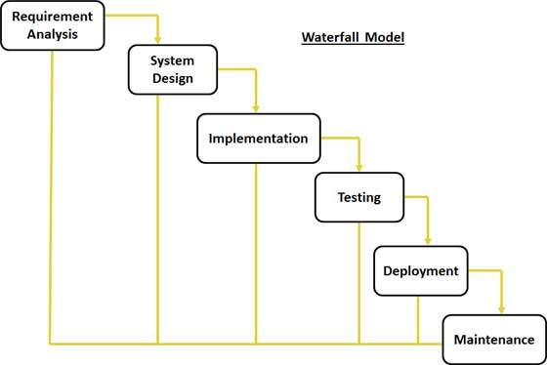

Figure1. Waterfall process model. (McGraw)

**2.2 Team Structure**

The team is utilizing a controlled decentralized structure. The team has picked Sapna Patil as team leader. The team leader’s part is to appoint the tasks to members in the team and to guarantee that gatherings remain focused. The group will meet each Tuesday and Thursday, in apartment 362 at an assigned time in Colony Park every week. In addition, the team might likewise meet at different times when considered important. The leader will show the plan for discussion, and the team will act together for all matters of the task.

**2.3 Communication**

Team will use “WhatsApp” group and emails for communication regarding project. So they can be in contact for 24/7. Team will have weekly meetings to check the status of the application and to track the milestones. In view of the examination, the project status would be controlled by the team. Correspondence with the client (Ms.Wuthrich) assumes a noteworthy part in the advancement of this application.

**2.4 Reporting**

The purpose of reporting is to manage the expectations of the client and instructor. Team members should send status updates to the team leader by the end of each Thursday. The team leader updates the work plan and solves issues on Tuesday, and then a status meeting is held by Thursday. This timing ensures that the team leader is up to date on all project activities at the end of the week and is prepared for a productive status meeting with the project team and the client at the beginning of the following week. In many cases where an issues arises, these issues will be entered into issue log as well as tracked and resolved. If things go out of control in the team, the issue would be examined with our instructor, Dr. Stringfellow and appropriate action will be taken by her to take being circumstances back to normal. The minutes of meeting and hours of work will be given credit in the objective grading sheet.

# 3. Project Resources

Resources are required to carry out the [project](https://en.wikipedia.org/wiki/Project) [tasks](https://en.wikipedia.org/wiki/Task_(project_management)). They are people, hardware and software which are required for the completion of a project activity. The lack of a resource will therefore, be a constraint on the completion of the project activity.

## 3.1 People

For this project, the project team consists of four members; each member has different tasks to perform. To complete the project with client’s requirements, people need to participate and develop the project successfully. The team members share different ideas, discuss which one is the best for the project.

We have below listed people as the team members for completing this project.

* Sapna Patil
* Saboor Siddiqie
* Mrudula Kosaraju
* Kranthi Paladugu

## 3.2 Hardware and Software

## The project requires both hardware and software. The team must possess knowledge of the hardware and software being used. If one of the member in team is not having knowledge on the project work, then the other person will help to understand him in timely fashion.

**Hardware: Minimum requirements**

Processor : Dual core

Memory Ram : 1 GB

Hard Disk : 40 GB

**Software: The system software requirement to run the application:**

Development : Microsoft visual studio 2013

Database : SQL Server 2008.

Operating System: Windows 7/8/8.1/10

Web browser : Internet Explorer, Chrome, Mozilla Firefox

**4. Risk Management**

The Church Financial Recordkeeping software development process involves several risks. Such risks should be analyzed and an appropriate method of correction should be addressed. Project risks include sickness of team member, delay, requirements alterations, and changes in the specifications, size underestimation and resource availability.

**4.1 Likely Risks**

Table 1 shows some of the possible potential risks, its impact and a strategy to deal with it.

Table 1. Risk Management Strategies.

|  |  |  |  |
| --- | --- | --- | --- |
| Risk | Chance | Impact | Strategy |
| Sickness of Team member | Low | Tolerable | Redistribute work  and reschedule members work |
| Delay | Very Low | Serious | Successive meeting  for monitoring project progress |
| Requirement Changes | Medium | Medium | Extra effort needed from all team members |
| Compatibility Constraints | Low | Serious | Additional Research |
| Lack of learning | High | Serious | Learn and practice concepts |
| Lack of resources ( time, human resource, materialistic resource ) | High | Serious | Preplan and acquire the resources |

As mentioned above, in the process of the system development, the team will encounter risks of several kinds. Management must devise plans to overcome each risk.

The team has good OOP concepts knowledge and a little hands-on practice with C# and user controls present in Visual Studio. The team will distribute the project work, and make an effort in building new features for the project and fixing bugs collectively.

## 4.2 Risks Management Plan

The team has identified risks, assessed risks and has developed strategies to manage risks in software design and in development which is known as Risk Management Plan as described in Figure 2. It is important part of project plan. This plan will help the team to identify risks and give a detailed strategy for dealing with each risk in project. The plan is also used to avoid the potential cost, schedule, performance and technical risk to a system.

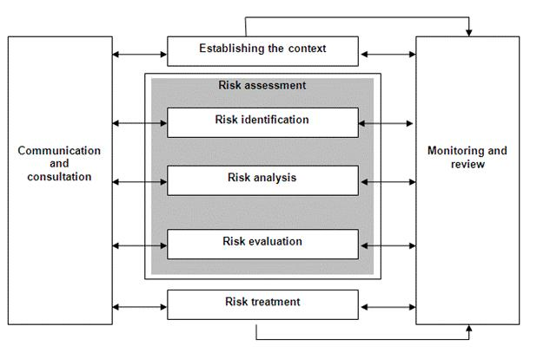

Figure 2. Risks Management Plan.

**5. Schedule**

The schedule for the project for each task is required to be completed. It shows the major phases one expects to find when using the Waterfall Process Model. It also shows the talk about duration, start, subtask, who is doing what? The group leader has drafted a schedule using Microsoft® Project, which includes meeting charts and calendars. Table 2. shows the Task List and Resource Allocation shows duration, start date, finish date, and resources allocated to each subtask.

Table 2. Task List and Resource Allocation.

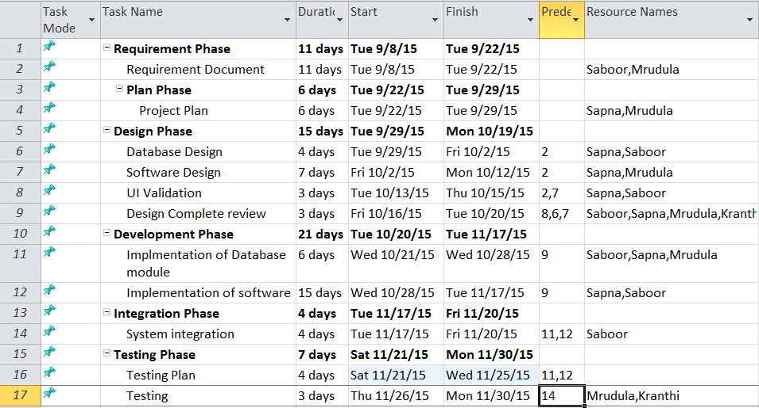

Figure 3. shows the Timeline shown below which divides the project into distinct tasks, allocating specific time slots to each, and indicating the responsible team member.

Figure 3. Timeline.

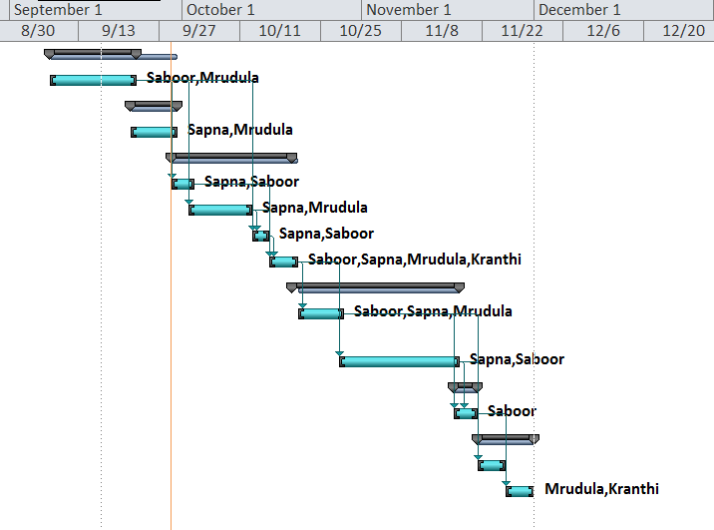

 Figure 4. shows the Task Network Diagram is a sequence of steps (activities), commonly represented by blocks, that are linked together in the logical sequence they need to be carried out.

Figure 4. Task Network Diagram.

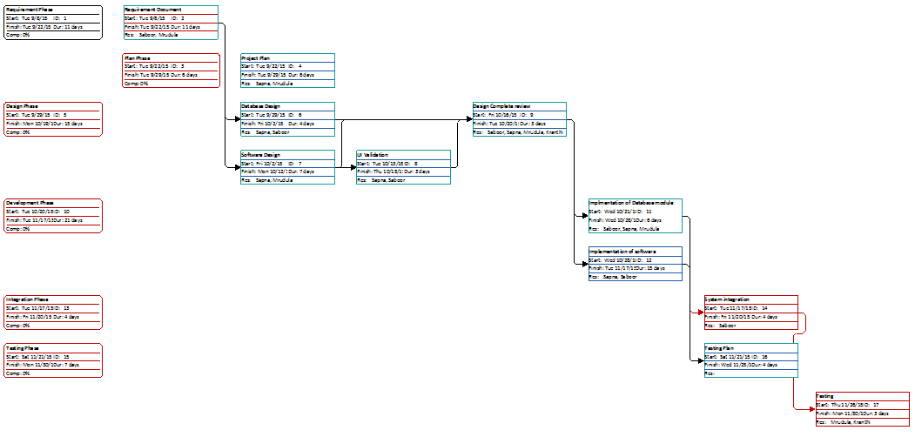

Table 3. Shows the objective grading sheet shows the credit given to each team member according to different phases of project.

Table 3. Objective grading sheet.

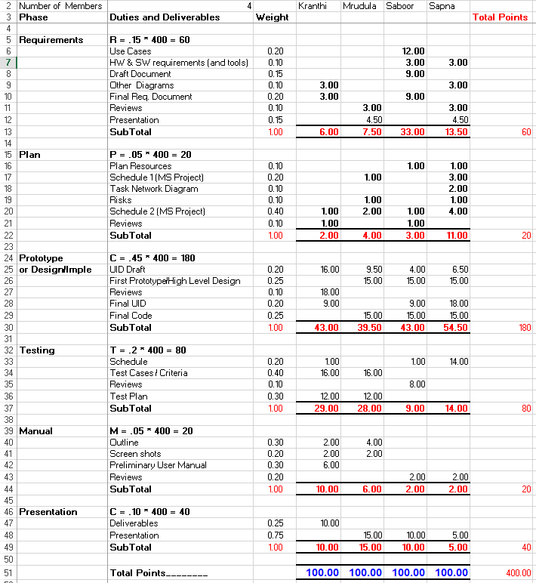

**6. Tracking and Control Mechanics**

The project will be monitored during the development process to catch any error that may arise. The group will develop a plan to test the software at various stages of the development. The group will also review the requirements and specifications plan to ensure no oversights

**6.1 File Tracking**

In order to keep track of files and documents regarding project, the team plans to use

GitHub. It is a web-based git repository hosting service. GitHub offers source code management functionality and also provides features like access control and collaboration features such as [bug tracking](https://en.wikipedia.org/wiki/Bug_tracking_system), [feature requests](https://en.wikipedia.org/wiki/Software_feature), [task management](https://en.wikipedia.org/wiki/Task_management) which are useful for project management.

**6.2 Project Tracking**

In Order to check the progress and status of the project, the team has a plan to utilize Microsoft Project. Microsoft Project will be used to schedule tasks of the project. The deadline is assigned each task. According to the schedule each task will be followed and monitored during each phase of development.

# 7. Glossary

Client – The party for which services are rendered.

Database – The file containing the collection of data for the software.

SQL Server – Database management software.

Microsoft® Project – Scheduling software from Microsoft Corporation.

Microsoft® Visual Studio – It’s a framework which will be used in designing and coding from Microsoft Corporation.

C#.net- It is Programming language provided by Microsoft.

Microsoft® Windows – A family of operating systems from Microsoft Corporation.

Waterfall Process Model **-** Framework for managing product development.

Requirements Document – An abstract system definition to help the client understand what the software will do.

Specification Document – A detailed statement outlining the software’s functionality and its constraints.

Team leader – Leader of the software development group.

Timeline – Schedule detailing a chronological sequence of events.

**8. References**

# McGraw, R. J. (2015, june 15). *FOXMIS*. Retrieved october 27, 2015, from Google: http://community.mis.temple.edu/mis2101sec711summer2015/

* Larman, C., Applying UML and Patterns: Introduction to Object-Oriented Analysis and Design and Iterative Development, 3rdedition (October 2004).
* Sommerville, I., Software Engineering 9th edition book, Pearson (March 2004).